Report for consumo normal con posibles pérdidas nocturnas o consumos nocturnos sin explicar

1. Time Series Characterization
Mean consumption: 96.17587939698493
Median consumption: 52.0
Std deviation: 114.05891014507215
Minimum consumption: 1
Maximum consumption: 472
95th percentile: 322.0
Total records: 398
Above Normal deviations: 2
Below Normal deviations: 0

2. Consumption Line Plot
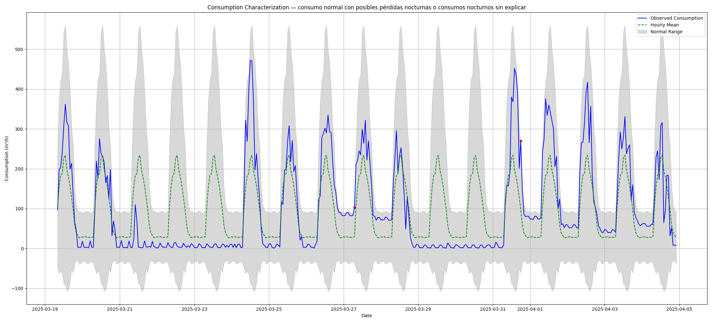

3. Deviation Heatmap
